**Calculator Free**

**Trigonometric Functions and Trigonometric Identities**

Time: 45 minutes

Total Marks: 45

Your Score: / 45



**Question One: [2, 3, 3 =8 marks]**

Describe the transformations that have transformed  to  in the situation below.

1.  
2.  
3.  

**Question Two: [2, 3, 3, 4 = 12 marks]**

Sketch each of the following functions on the axes below:

1. 

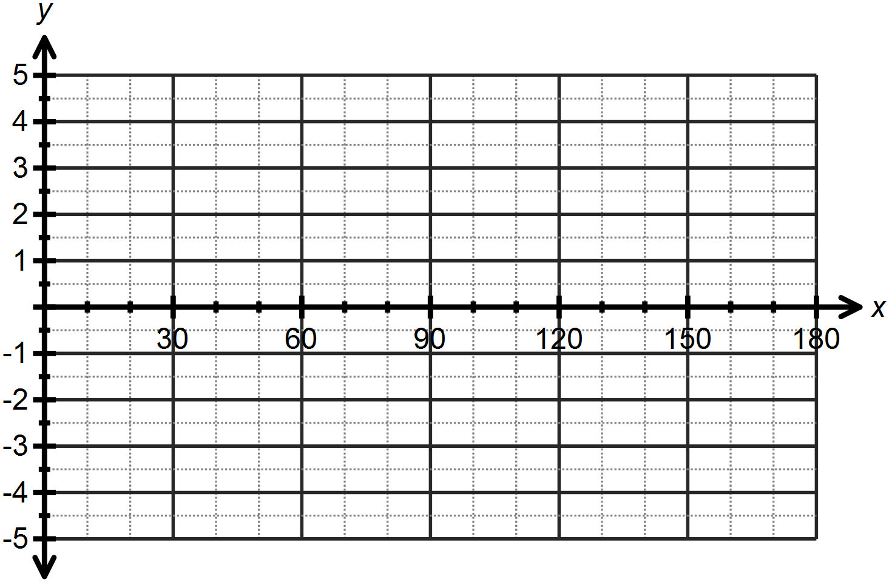

1. 

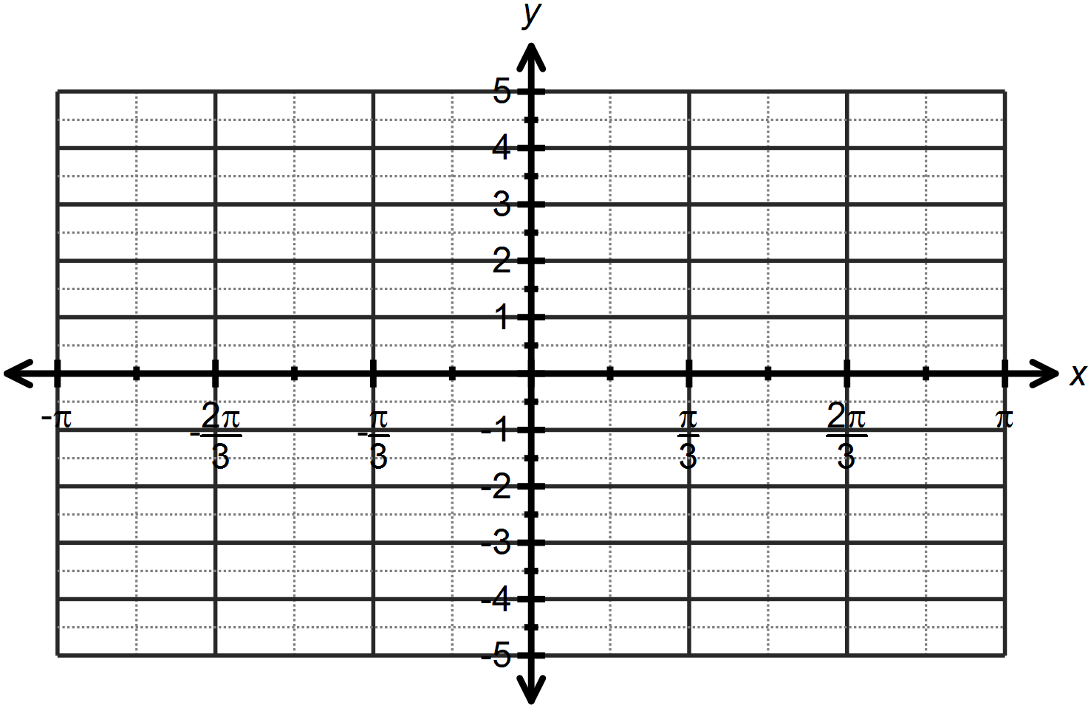

1. 

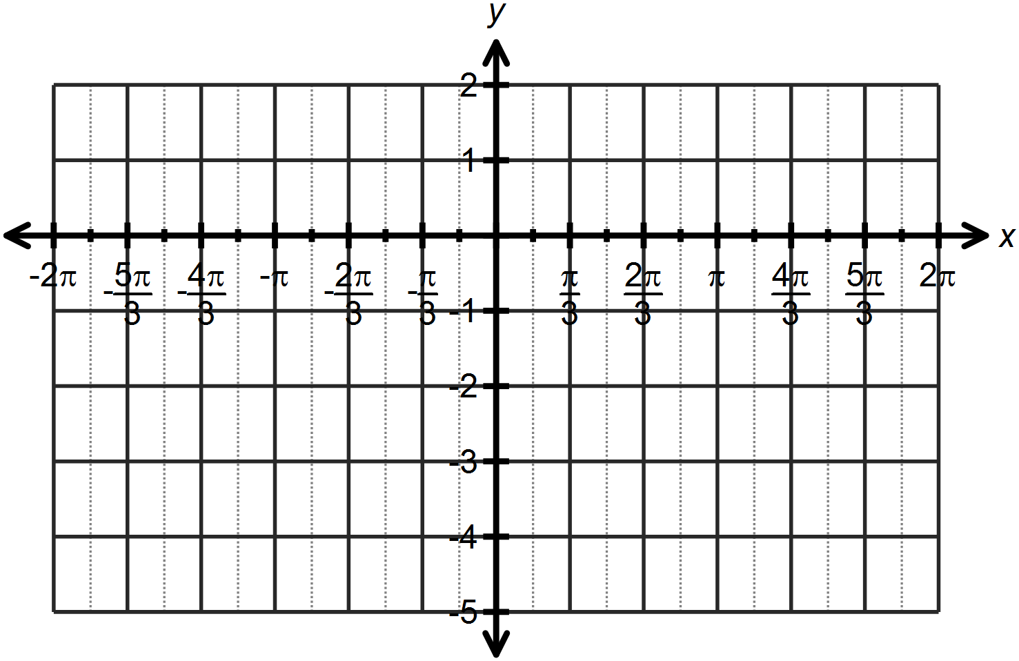

1. 

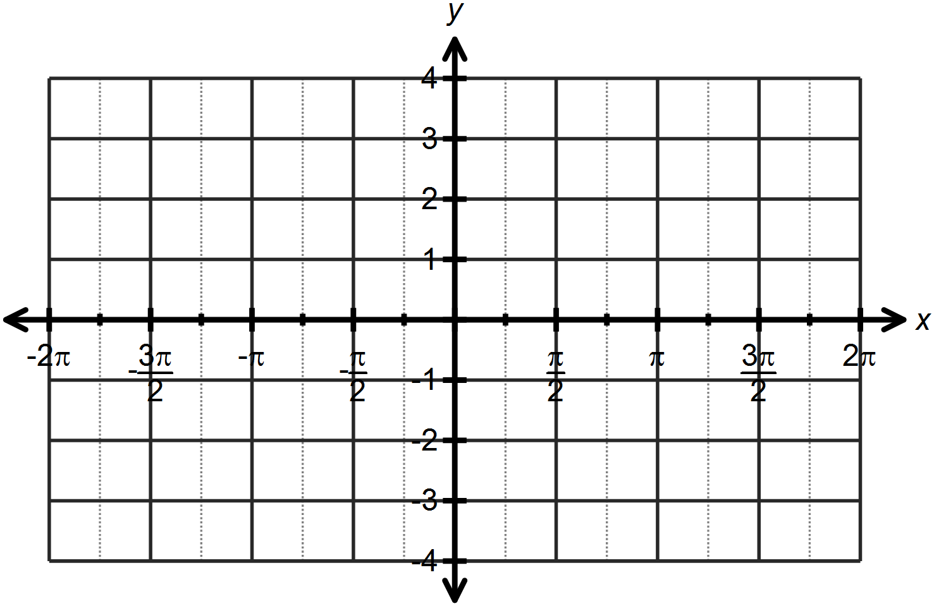

**Question Three: [2, 2, 2 = 6 marks]**

Calculate the values of the unknowns for each of the following:

1. 
2. 
3. 

**Question Four: [5 marks]**

Determine the equation of the graph drawn below as both a sine and a cosine function.

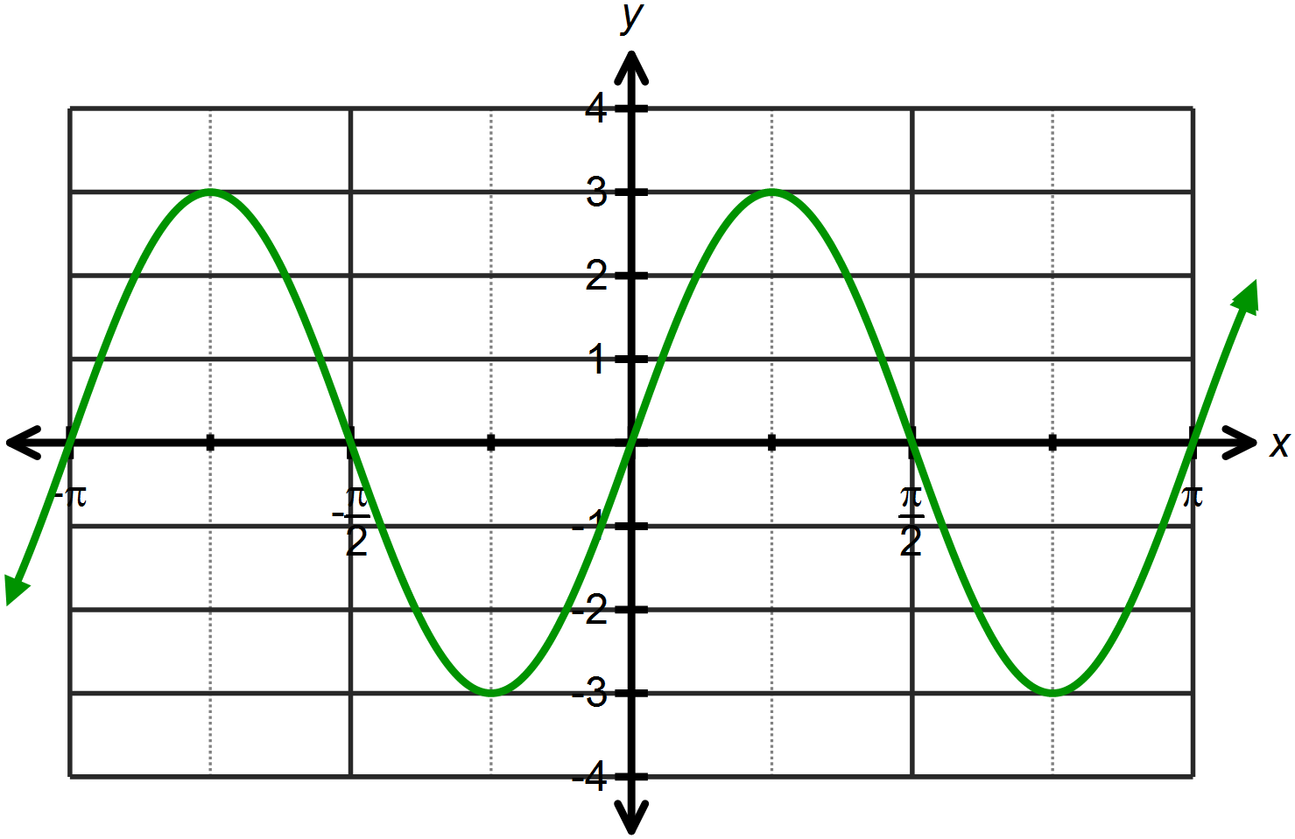

**Question Five: [3, 3, 4, 4 = 14 marks]**

Use the angle sum or difference property to find the exact value for each of the following, simplifying all answers.

1. 
2. 
3. 
4. 

**SOLUTIONS**

**Calculator Free**

**Trigonometric Functions and Trigonometric Identities**

Time: 45 minutes

Total Marks: 45

Your Score: / 45



**Question One: [2, 3, 3 =8 marks]**

Describe the transformations that have transformed  to  in each situation below.

1.  



Horizontal dilation scale factor ½



Vertical dilation scale factor 3

1.  

Translate  units right

Reflect about the  *x* – axis



Translate 1 unit up

1.  

Horizontal translation left

Horizontal dilation scale factor 2

**Question Two: [2, 3, 3, 4 = 12 marks]**

Sketch each of the following functions on the axes below:

1. 

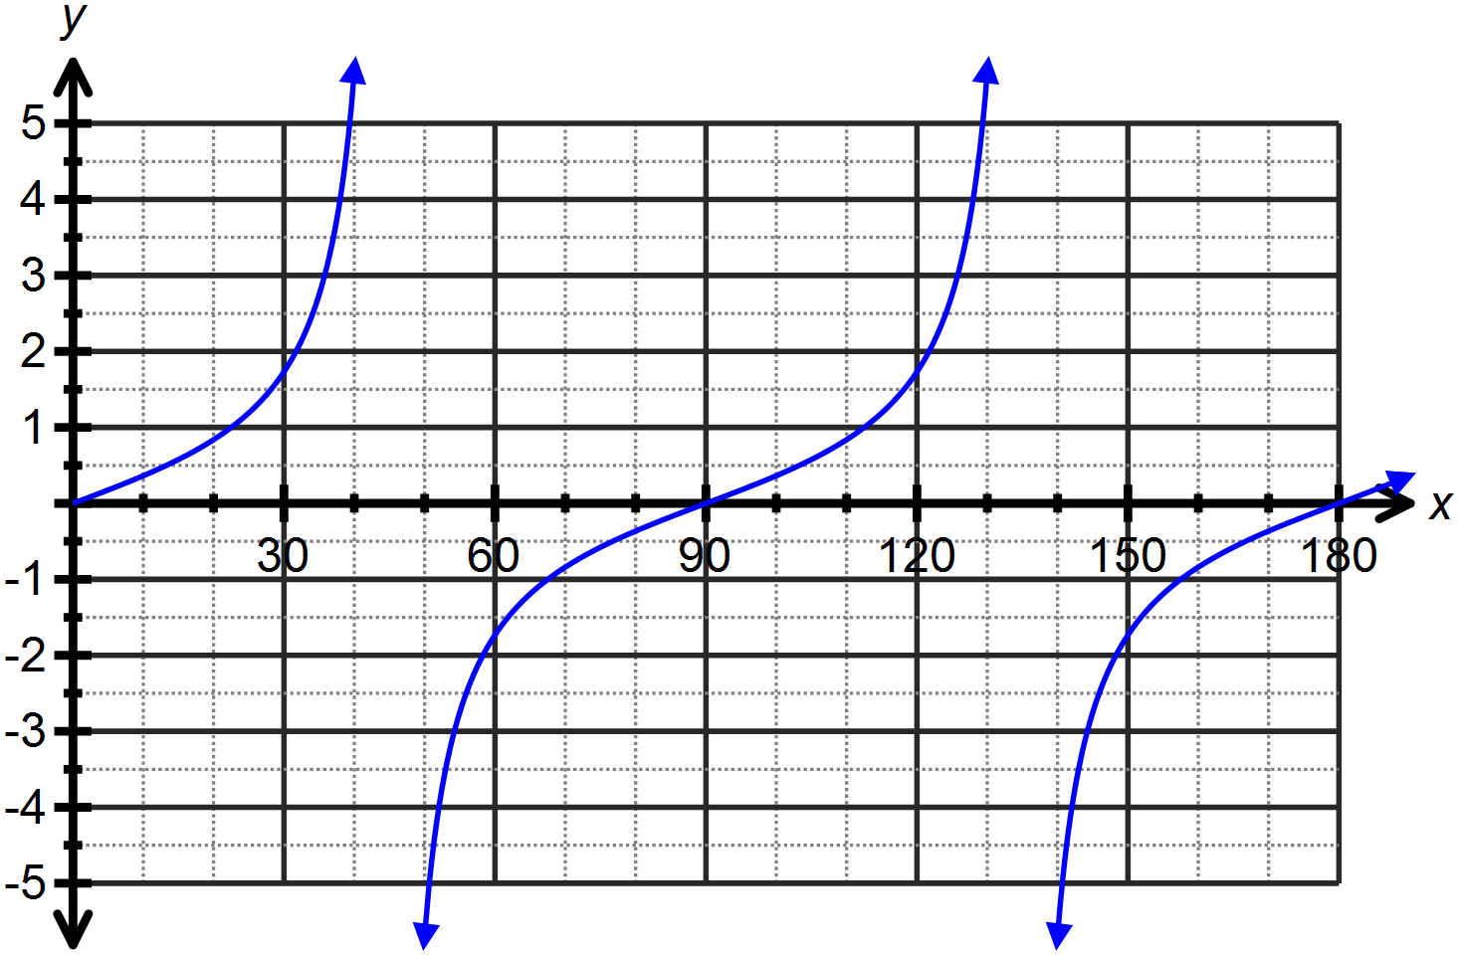



1. 

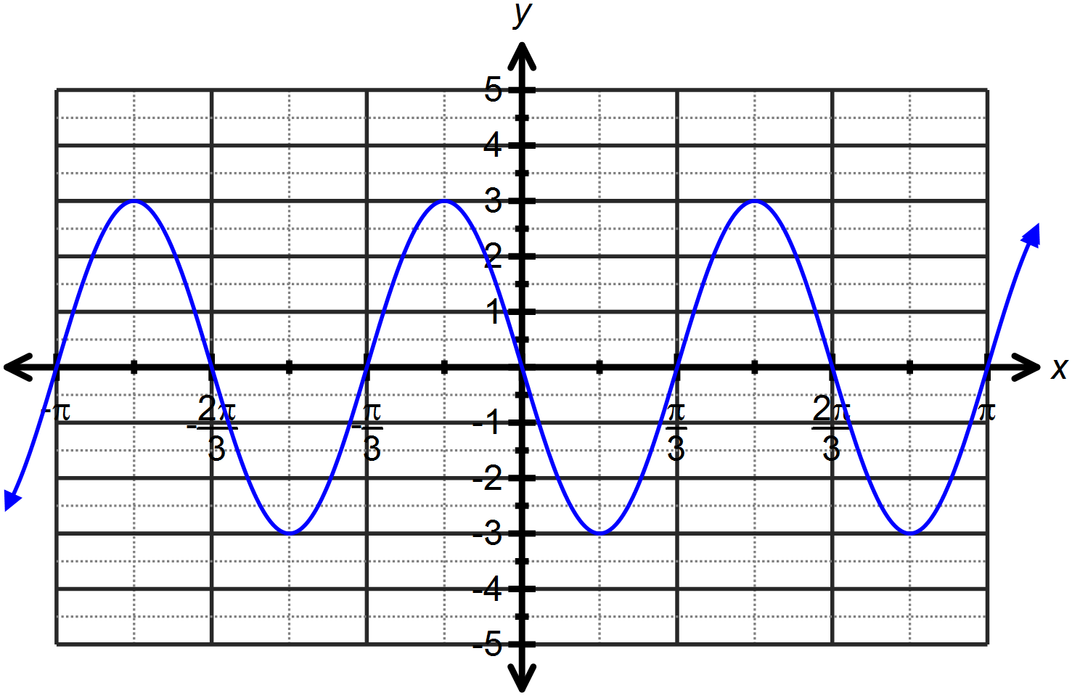







1. 

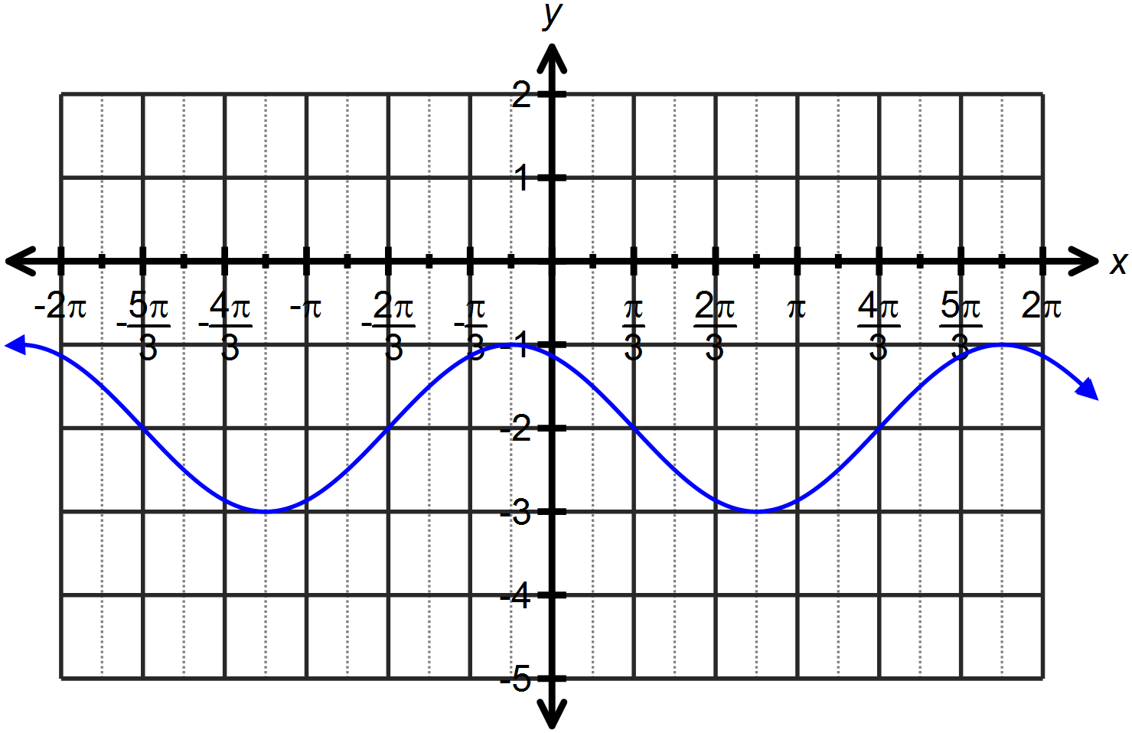







1. 

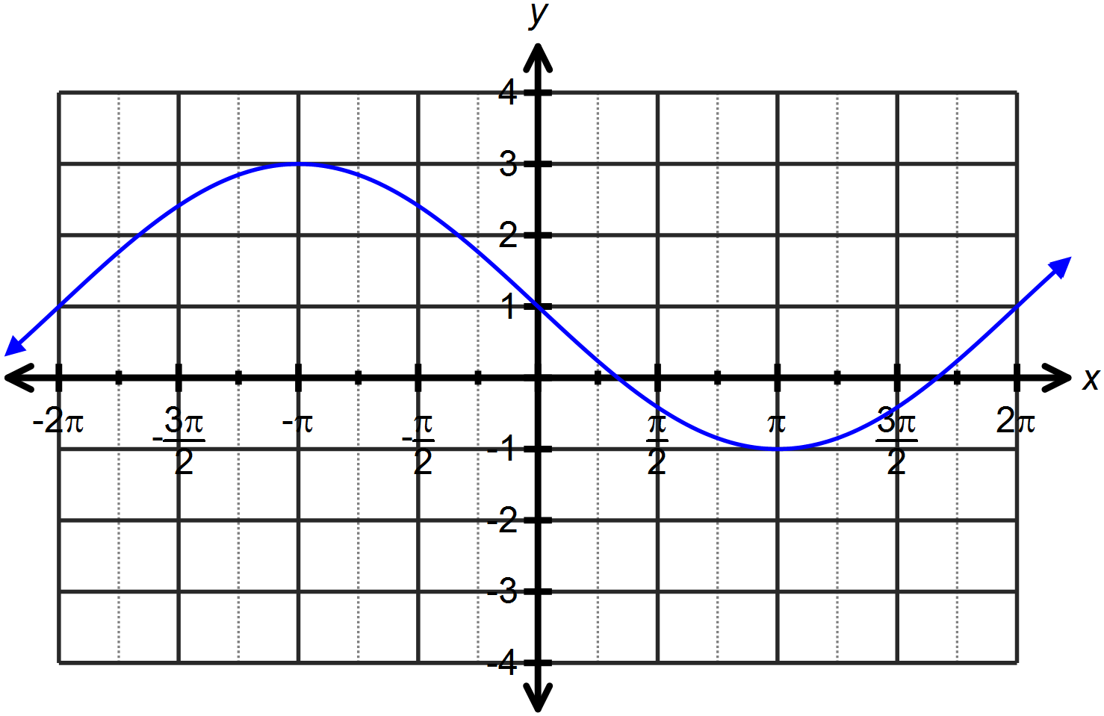







**Question Three: [2, 2, 2 = 6 marks]**

Calculate the values of the unknowns for each of the following:

1. 



1. 



1. 



**Question Four: [5 marks]**

Determine the equation of the graph drawn below as both a sine and a cosine function.







**Question Five: [3, 3, 4, 4 = 14 marks]**

Use the angle sum or difference property to find the exact value for each of the following, simplifying all answers.

1. 



1. 



1. 





1. 



